**GIGA ETHERNET MEDIA CONVETER**

**MODEL: DYS1000 SERIAL**

**Overview:**

DYS1000 Series Fiber Media Converters Card can convert Optical-Electric Ethernet signals between 10/100/1000M UTP interface (TX) and 1000M optical fiber interface (FX). It can extend traditional 10/100/1000M Gigabit Ethernet to the distance of 120km through optical fiber link. It possesses stable performance and good quality by adopting latest IC packages from USA and Taiwan. 6 Group LED indicated lights could fully monitor the working conditions of Converters. It is easy for end users to observe network operation. DYS1000 Serial Media Converter Card could be used alone, them can inserted to 14 slots Converters Rack supplied by DYS Crop ( RACK2000). Suitable for the use of Network Centre...

**Picture:**

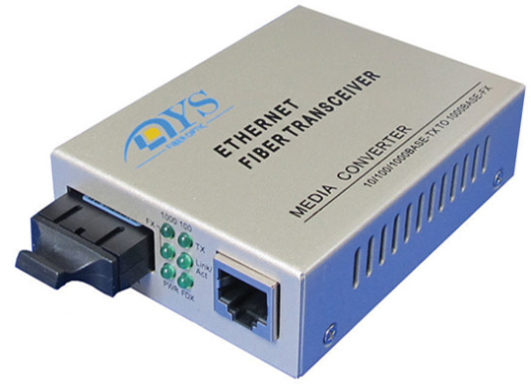

**Main features:**

* Auto negotiation function allows UTP port to auto select 10M, 100M or 1000M, and Full Duplex or Half
* Duplex auto-sensed.
* UTP port supports MDI/MDI-X auto crossover.
* Indicator function of link fault (LFP): When optical fiber or UTP is at fault, the converter could stop all the link.
* Multiple Optical Transceiver could be chosen: SC, ST or FC, single-mode / multi-mode
* Supporting 1600 bytes packet for management
* Converter working mode could be chosen: Store and forward switch mode, Modified cut-through switch mode, or Converter mode.
* Internal Circuit of prevented thunder could greatly reduce damage of the converter caused by thunderbolt induction.
* Internal or External switching power: for users to choose.

**Specifications:**

Operating standards: IEEE 802.3 10Base-T, IEEE 802.3u 100Base-TX, IEEE 802.3ab 1000Base-TX, IEEE 802.3z 1000Base-FX Flow control.

* MAC addresses table: 1K
* Data buffer: Built-in 128Kbyte RAM
* Connectors: UTP Connector: RJ-45, 10/100/100Base-T,
* Fiber Connector: ST/SC/FC, 1000Base-FX
* Cable:
  + UTP: Cat. 5 (the max distance up to 100m)
  + Dual-fiber Multi-mode: 550m (Fiber size: 62.5/125μm)/ 2Km (fiber size: 50/125μm)
  + Dual-fiber Single-mode: 20/40/60/80/100/120Km; Single-fiber Single-mode: 25/40/60/80Km.
* Flow Control
  + Full Duplex: Supporting standard IEEE802.3
  + Half Duplex: back pressure

1. Ethernet Port

* Compatible with IEEE 802.3 series Standards
* Speed: 10/100/1000Mbps auto-negotiation
* Duplex: Half/full auto-negotiation
* Connectors: RJ45 Jack
* MDI/MDI-X crossover automatically

2. Optical Port

* Wavelength: 850nm/1310nm/1550nm
* Speed: 1.25GB/s
* Single mode/Multimode Optional
* Up to 120km transmission distance
* SC/PC, ST/PC and FC/PC optional ( Or SFP Slots)

3. Power

* Input DC: 5 VDC
* Consumption: Standalone < 1W

4. Power Adapter

* Input: 85VAC~265VAC, 0.2A, 50/60Hz
* Output: 5VDC, 1A

5. Environment

* Temperature: 5°C ~ 40°C;
* Humidity: 30% ~ 90% (25°C);

6. LEDs

PWR, FDX, LINK, ACT, FX, TX 100

**Information Order:**

|  |  |  |  |  |  |
| --- | --- | --- | --- | --- | --- |
| **Type** | **Data Rate** | **Connector** | **Fiber type** | **Wavelength (nm)** | **Max. distance** |
| DYS1000-SC-1.5 | 1.25G | SC Duplex | Multi-mode | 850 | 550m |
| DYS1000S-SC-20 | 1.25G | SC Duplex | Single-mode | 1310 | 20km |
| DYS1000S-SC-40 | 1.25G | SC Duplex | Single-mode | 1310 | 40km |
| DYS1000S-SC-60 | 1.25G | SC Duplex | Single-mode | 1550 | 60km |
| DYS1000S-SC-80 | 1.25G | SC Duplex | Single-mode | 1550 | 80km |
| DYS1000S-SC-100 | 1.25G | SC Duplex | Single-mode | 1550 | 100km |
| DYS1000S-SC-120 | 1.25G | SC Duplex | Single-mode | 1550 | 120km |
| DYS1000SS-SC-20 | 1.25G | SC Simplex | Single-mode | 1310/1550 | 20km |
| DYS1000SS-SC-40 | 1.25G | SC Simplex | Single-mode | 1310/1550 | 40km |
| DYS1000SS-SC-60 | 1.25G | SC Simplex | Single-mode | 1490/1550 | 60km |
| DYS1000SS-SC-80 | 1.25G | SC Simplex | Single-mode | 1490/1550 | 80km |

|  |  |  |
| --- | --- | --- |
| **DYSFO** | | |
| **ShenZhen DYS Fiber optic Technology Co.,Ltd**  Tel: 86-0755-29518585, 29650336 Fax : 86-0755-29510505 PC/ZIP: 518133  Add: 2/F, 7 Building, Tangtou Industrial Zone 3rd, Shiyan Town, BaoAn District, Shenzhen, P.R China | | |
|  |  |  |